**Experiment 3 Date:** 06/03/2023

# Aim:

Familiarization of Linux Commands

# Course Outcome(CO2):

Perform system administration task

# Procedure:

1. pwd :- print working directory

$pwd Output:



1. ls :- list directory content

$ls Output:



* 1. ls -R :- list subdirectories recursively

$ls -R Output:



* 1. ls -l :- Use long listing format

$ls -l Output:

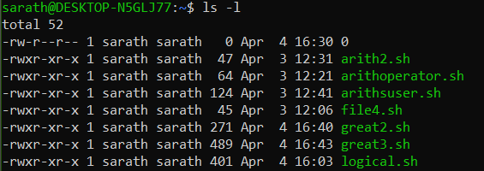

* 1. ls -a :- List hidden files

$ls -a

Output:

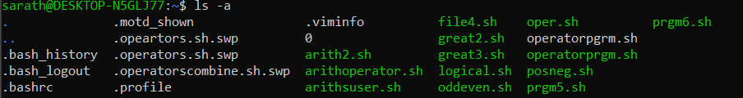

* 1. ls -al :- list files and directories with detailed information such as permissions, size and owner

$ls -al Output:

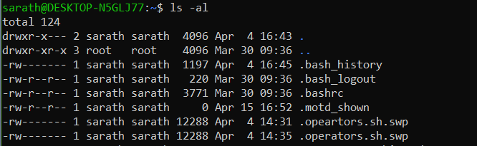

* 1. ls -t :- Sort by modification time, newest first

$ls -t Output:

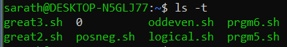

* 1. ls -r :- Reverse order while sorting

$ls -r Output:



1. history : - Review all previously executed commands right from the shell

$history Output:

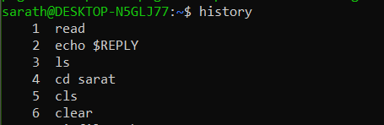

1. man :- An interface to system reference manuals

$man ls Output:

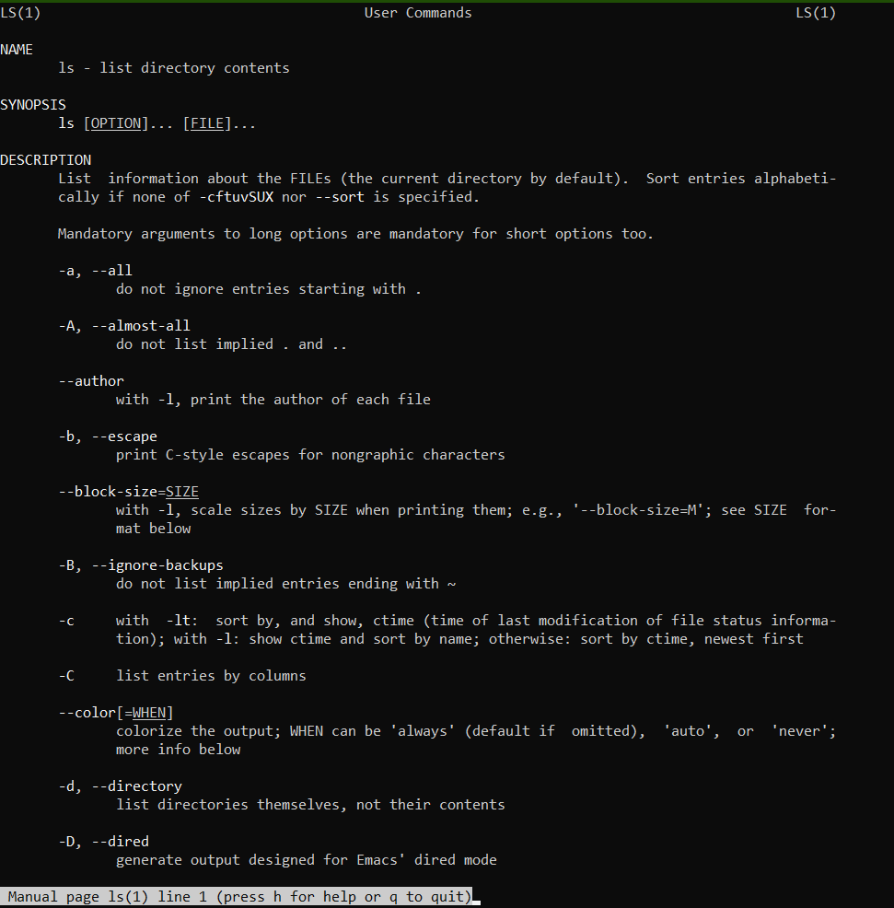

1. cd :- Change directory

$cd Output:



1. mkdir :- Make directory

$mkdir mca Output:



1. rmdir :- Remove empty directories

$rmdir mca Output:

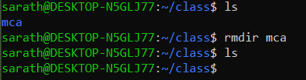

1. touch :- Create empty file

$touch

Output:



1. cat :- Concatenate files and print on the standard output
   1. cat > sr.txt :- Create and write in new file

$cat > sr.txt Output:



* 1. cat sr.txt :- Print contents of the file

$cat sr.txt Output:



* 1. cat >> sr.txt :- Append information in already existing file

$cat >> sr.txt Output:

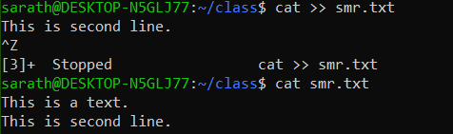

* 1. cat sr.txt file.txt > output.txt :- Copy contents of two files to a third new file

$cat sr.txt file.txt > output.txt Output:

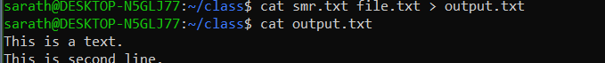

* 1. cat -n output.txt :- Number all output lines

$cat -n output.txt Output:



* 1. cat -b sr.txt :- Remove numbering for empty lines

$cat -b sr.txt

Output:

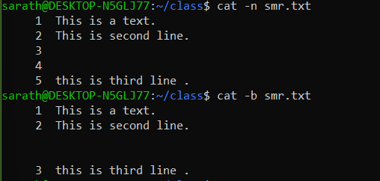

* 1. cat -e output.txt :- Display $ at end of each line

$cat -e output.txt

Output:



* 1. cat << EOF :- Displays an end marker at the end of a file.

$cat > file1.txt <<EOF

Output:

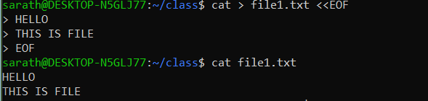

* 1. cat file1.txt | tr a-z A-Z > output1.txt :- To change content to uppercase

$cat file1.txt | tr a-z A-Z > output.txt Output:

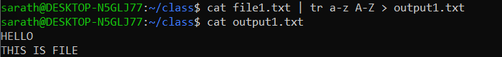

# Result:

Output displayed successfully and CO2 was obtained.

**Experiment 4: Date:** 07/03/2023

# Aim:

Familiarization of Linux Commands

# Course Outcome(CO2):

Perform system administration task

# Procedure:

1. cut :- For cutting out the sections from each line of files and writing the result to standard output
   1. cut -b1 :- Cut by first byte position

$cut -b1 file1.txt Output:



* 1. cut -c3 :- Cut by third character

$cut -c3 file1.txt Output:



* 1. cut -d - -f1 file3.txt :- Cut by delimiter

$cut -d - -f1 file3.txt Output:

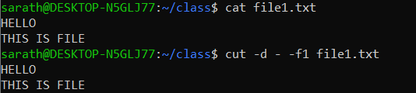

* 1. cut -c :- Select only these characters

$cut -c 1,3,5 file3.txt Output:



1. Paste :- Merge lines of files

$paste sr.txt file1.txt Output:

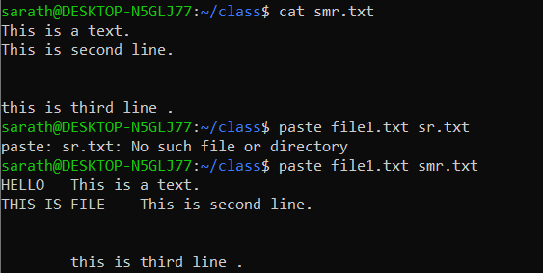

* 1. paste file1.txt output.txt> output3.txt :- Paste the merged content to new file

$paste file1.txt output.txt > output3.txt Output:

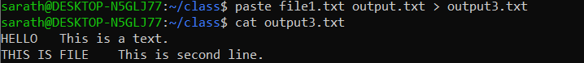

* 1. paste -d ‘%’ file3.txt output.txt :- Separate the merged parts using a symbol(%)

$paste -d ‘%’ file3.txt output.txt Output:



* 1. paste -s output.txt :- Display output in a single line

$paste -s output.txt Output:



1. cp :- Copy the content
   1. cp file3.txt sr.txt : -Overwrite existing file

$cp file3.txt sr.txt

Output:

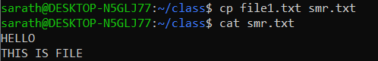

* 1. cp sr.txt output5.txt :- Copy into new file

$cp sr.txt output5.txt

Output:

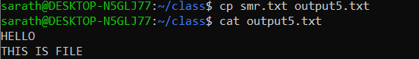

* 1. cp -r class mca :- Copy directories and subdirectories from existing directory to a new one

$cp -r class mca

Output:

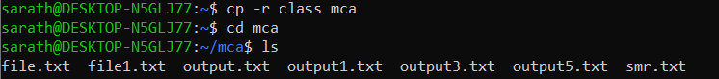

* 1. cp newfile class:- Copy file from one directory to another

$cp newfile class Output:



# Result:

Output displayed successfully and CO2 was obtained.

**Experiment 5 Date**: 13/03/2023

# Aim:

Familiarization of Linux Commands

# Course Outcome(CO2):

Perform system administration task

# Procedure:

1. read :- Read content of one line of input into a variable

$read

echo $REPLY :- To print the input from the default variable

Output:

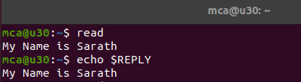

* 1. read var1 var2 var3 :- To read into specific variables

$read var1 var2 var3

$echo “[$var1][$var2][$var3]” Output:

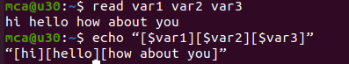

* 1. read input \ :- To read multiple lines

$read My \ name is \ Sreerag Output:

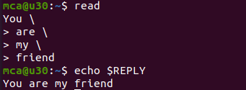

* 1. read -p :- Prompt text from user

$read -p “Enter your name”

$echo “my name is $REPLY” Output: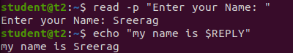

* 1. read -n :- Specify limit

$read -n 6 -p “Enter six characters only” Output:

* 1. read -s :-For security. Hides input

$read -s -p “Enter the password: “ Output:

1. wc :- Word count display number of lines, number of words, number of bytes and file name

$wc file.txt Output:

* 1. wc -l :- Display number of lines

$wc -l file.txt Output:

* 1. wc -m :-Display number of bytes

$wc -m file.txt Output:

* 1. wc -c :- Display number of characters

$wc -c file.txt Output:

* 1. wc -w :-Display number of words

$wc -w file.txt Output:

* 1. wc -L :- Displays length of longest line

$wc -L file.txt Output:

1. more :- It is similar to cat to display the content. The difference is that in case of larger files, cat command output will scroll off your screen while more command display output one screenful at a time.

$more finalfantasy.txt Output: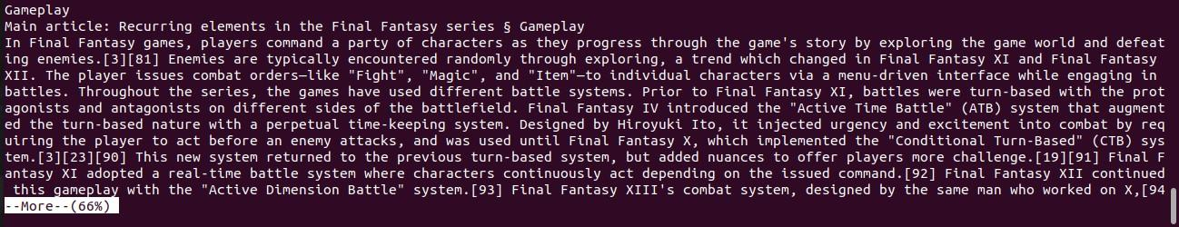

* 1. more +15 file.txt :- Will display content after the specified number of lines

$more +15 finalfantasy.txt Output:

￼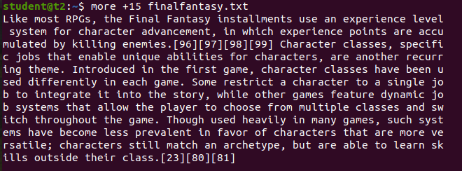

* 1. more +/pattern file.txt :- Search and navigate towards a particular string and view all the instances.

$more +/classes finalfantasy.txt

Output: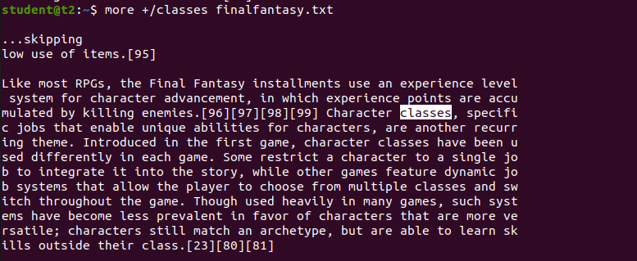

* 1. more -p file.txt :- Clear the whole screen and then display the text.

$more -p file.txt Output: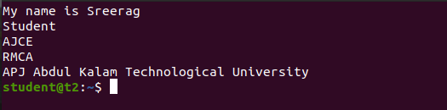

* 1. more -d file.txt :- Helps the user to navigate according to instructions, [space to continue and ‘q’ to quit]

$more -d finalfantasy.txt Output: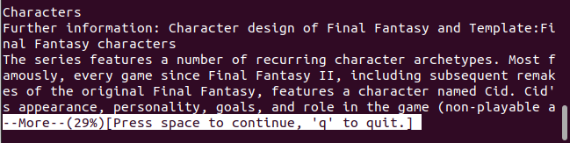

# Result:

Output displayed successfully and CO2 was obtained.

**Experiment 6: Date:** 14/03/2023

# Aim:

Familiarization of Linux Commands

# Course Outcome(CO2):

Perform system administration task

# Procedure:

1. grep :- Filtering and Searching content easily

$gerp 34 Mark Output:

* 1. grep -i :- Case insensitive search of a particular content￼

$grep -i 42 Mark Output:

* 1. grep -v :- Exclude that content during search￼￼￼￼

$grep -v 42 Mark Output:

* 1. grep -A1 :- Specific content and one line after the content

$grep -A1 Maths Mark Output:

* 1. grep -B1 :- Specific content and one line before the content

$grep -B1 Maths Mark Output:

* 1. grep -C1 :- Specific content and one lone before and after the content.

$gerp -C1 Maths Mark Output: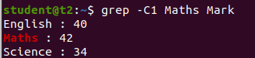

1. head :- Used to display the first content of the file(Top 10 lines by default)

$head numbers Output:-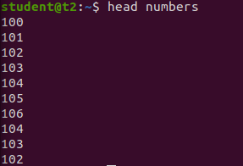

* 1. head -number filename:- Specific number of lines

$head -5 numbers Output: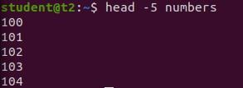

1. tail:- Used to display last contents of a file( last 10 by default)

$tail numbers Output: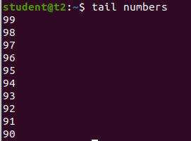

* 1. tail -number filename :- Specific number of content from last

￼￼$tail -5 numbers Output: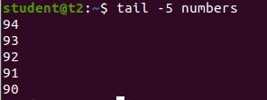

1. mv :- move from one location to another or it can be used to rename a file. Content will be overwritten.

$mv numbers Mark Output:-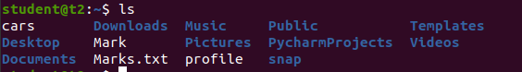

* 1. mv -b :- To take backup of a file while moving.

$mv -b Mark profile Output: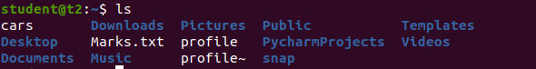

* 1. mv -i :- Prompt confirmation from user before overwriting.

$mv -i Marks.txt profile Output:

# Result:

Output displayed successfully and CO2 was obtained.

**Experiment 7 Date:** 20/03/2023

# Aim:

Familiarization of Linux Commands

# Course Outcome(CO2):

Perform system administration task

# Procedure:

1. expr :- Evaluate the given expression and display the output.

$expr 12 + 8 Output:

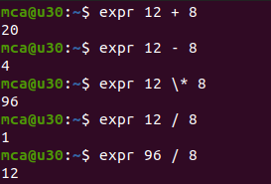

* 1. expr x + y :- Add two variables obtained through read

$read x

$read y

$expr $x + $y Output:

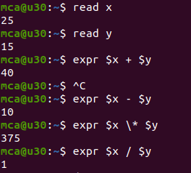

1. df :- Get a report on disk utilization of the system

$df Output:

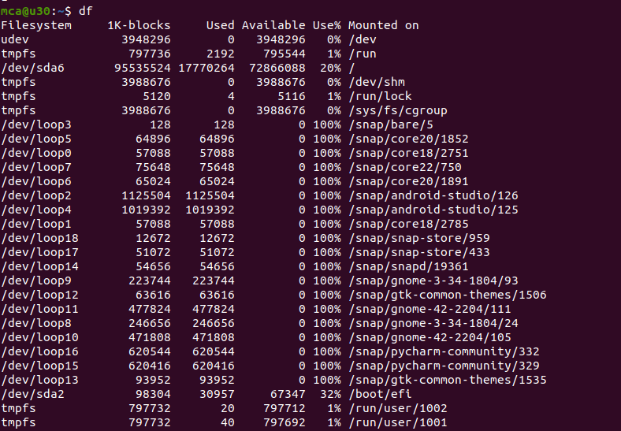

1. du :- check how much space a file or directory in a given directory

$du file.txt Output:

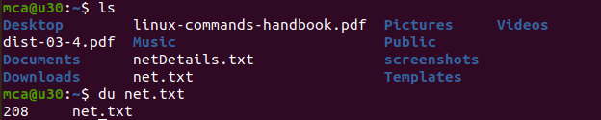

1. sudo :- superuser do
   1. sudo useradd user :- Add new user

$sudo useradd Sreerag Output:

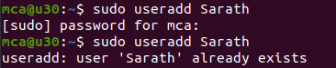

* 1. sudo passwd user :- Update password of the user

$sudo passwd Sreerag Output:

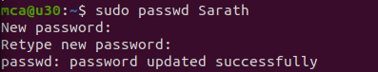

* 1. sudo groupadd -g identifier name:- To create new group

$sudo groupadd -g 269 mcastd

* 1. sudo usermod -G name user :- Add users to group

$sudo usermod -G mcastd Sreerag



* 1. id user :- Details on group name and numeric id of particular user.

$id Sreerag Output:



1. compgen -g :- Display all the groups created

$compgen -g Output:

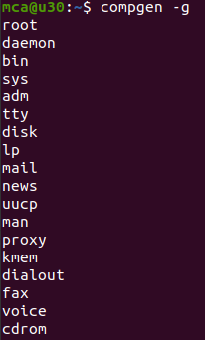

1. chmod :- Used to change the access permissions of files and directories. It stands for change mod namely, read(r), write(w), execute(x)
   1. chmod -wx file :- deny permission to write and execute for file

$chmod -wx file Output:



* 1. chmod +wrx file :- give permission to write, read and execute for a file

$chmod +wrx file Output:

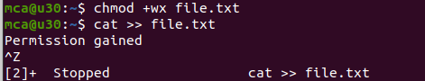

1. sudo chown :- Used to change ownership of a file or directory for a user or a group. It stands for change owner.

$sudo chown Sreerag file Output:

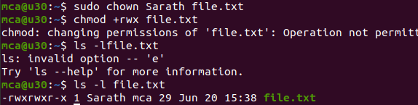

1. sudo userdel user :- Delete user

$sudo userdel Sreerag Output:



1. sudo groupdel name :- Delete group

$sudo groupdel mcastd Output



# Result:

Output displayed successfully and CO2 was obtained.

**Experiment 8 Date:** 21/03/2023

# Aim:

Familiarization of Linux Commands

# Course Outcome(CO2):

Perform system administration task

# Procedure:

1. ip addr:- Get ip address of the system

$ip addr Output: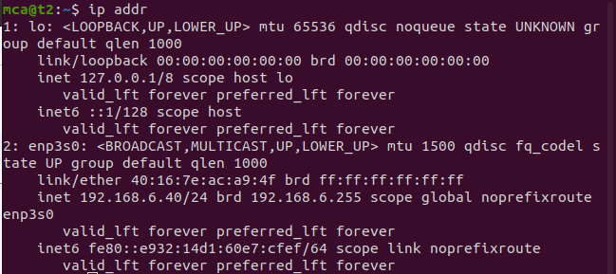

1. ssh user@ip address:- Stands for Secure Shell Protocol used to securely connect to a remote server or system. ssh is secure in the sense that it transfers data in encrypted form between host and client.

$ssh [mca@192.168.6.39](mailto:mca@192.168.6.39) Output:

* 1. sudo apt-get install openssh -server :- Update port
  2. sudo ufw allow 22

$sudo ufw allow 22 Output:

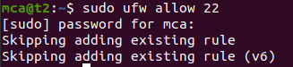

c. $ssh [mca@192.168.6.28](mailto:mca@192.168.6.28) Output: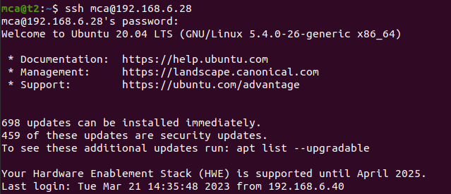

d. ssh-keygen :- Generating a key for secure shell

$ssh-keygen Output: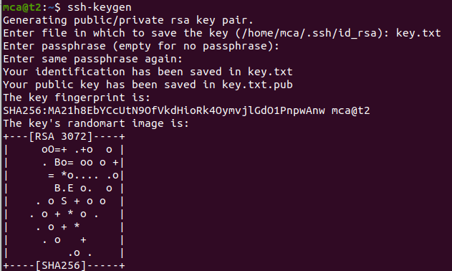

1. ps :- Stands for Process. Currently running programs and running instances.
   1. $ps

Output: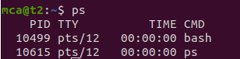

* 1. Ps-u :- Display all running processes of a particular user

$ps –u mca

Output :

* 1. ps-C :- Specific process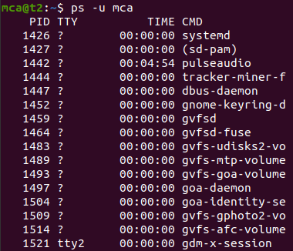

$ps-C firefox

Output:

* 1. Ps-f –p PID :- List the process by id

$ps –f-p 2762

Output:

# Result:

Output displayed successfully and CO2 was obtained.

**Experiment 9 Date:** 28/03/2023

# Aim:

Familiarization of Linux Commands

# Course Outcome(CO4):

Write shell scripts required for system administration

# Procedure:

1. Shell script to display date:

$vi filename.sh :- Open Editor by creating a shell script file.

Press ‘i’ to INSERT

#!/bin/bash :- To indicate the shell used date

Press ‘Esc’ to end INSERT

:wq! :- To save and quit

chmod +x filename.sh :- To give execution permission

./filename.sh :- To execute shell script Output:

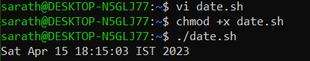

1. Shell script to display your name:

$vi filename.sh Press ‘i’ to INSERT #!/bin/bash

echo “What is your name?” read name

echo “My name is $name” Press ‘Esc’ to end INSERT

:wq!

chmod +x filename.sh

./filename.sh Output:

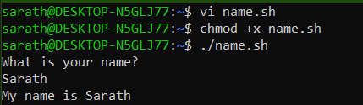

1. Multiple Commands (ls, pwd, date, mkdir) in Shell Script:

$vi filename.sh Press ‘i’ to INSERT #!/bin/bash

date ls pwd

mkdir files

Press ‘Esc’ to end INSERT

:wq!

chmod +x filename.sh

./filename.sh Output:

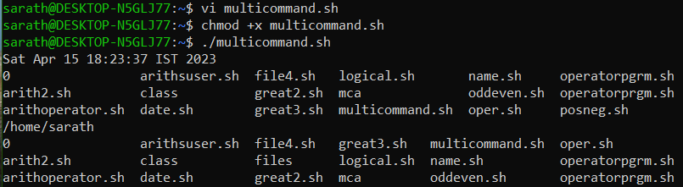

1. Shell script to demonstrate variables

$vi filename.sh Press ‘i’ to INSERT #!/bin/bash

echo “Enter your name: “ read name

echo “Your name is $name” echo “File Name: $0”

echo “First Parameter: $1” echo “Second Parameter: $2” echo “Quoted Values: $@” echo “Quoted Values: $*”

echo “Total Number of Parameters: $#” Press ‘Esc’ to end INSERT

:wq!

chmod +x filename.sh

./filename.sh Output:

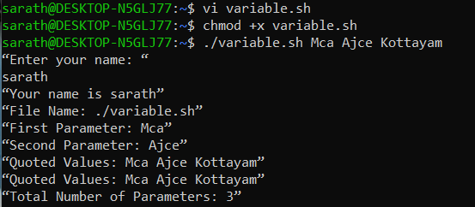

1. Shell script to count lines and words in a file

readlink -f filename :- Get path of required file

$vi filename.sh Press ‘i’ to INSERT #!/bin/bash

file_path = “/home/Reqfilename.sh” countlines = `wc –lines < $file_path` countwords = `wc –words < $file_path` echo “Number of lines: $countlines” echo “Number of words: $countwords” Press ‘Esc’ to end INSERT

:wq!

chmod +x filename.sh

./filename.sh Output:

1. Shell script to display array index

$vi filename.sh Press ‘i’ to INSERT #!/bin/bash Name[0] = “name1” Name[1] = “name2”

Name[2] = “name3” Name[3] = “name”

echo “First Index: ${Name[0]}” echo “Second Index: ${Name[1]}” Press ‘Esc’ to end INSERT

:wq!

chmod +x filename.sh

./filename.sh Output:

# Result:

Output displayed successfully and CO4 was obtained.

**Experiment 10 Date:** 03/04/2023

# Aim:

Familiarization of Linux Commands

# Course Outcome(CO4):

Write shell scripts required for system administration

# Procedure:

1. Shell script to add two number: vi filename.sh

Press ‘i’ to INSERT #!/bin/bash value=`expr 2 + 13`

echo "Total value : $value" Press ‘Esc’ to end INSERT

:wq!

chmod +x filename.sh

./filename.sh Output:

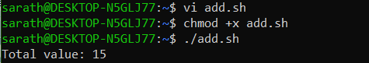

1. Write a shell script to initialize two numeric variables. Then perform addition operation on both values and store the result in the third variable.

vi filename.sh Press ‘i’ to INSERT #!/bin/bash num1=12

num2=48

sum=$(( $num1 + $num2 )) echo "Sum : $sum"

Press ‘Esc’ to end INSERT

:wq!

chmod +x filename.sh

./filename.sh Output:

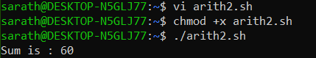

1. Shell script to read two numbers as command line parameters and perform the addition operation

vi filename.sh Press ‘i’ to INSERT #!/bin/bash sum=$(( $1 + $2 )) echo "Sum : $sum"

Press ‘Esc’ to end INSERT

:wq!

chmod +x filename.sh

./filename.sh num1 num2 Output:

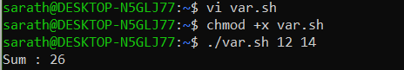

1. Shell script which takes input from the user at run time and then calculate the sum of given number and store to a variable and show the result

vi filename.sh Press ‘i’ to INSERT #!/bin/bash

read -p "Enter the First number: " num1 read -p "Enter the Second number: " num2 sum=$(( $num1 + $num2 ))

echo "Sum : $sum"

Press ‘Esc’ to end INSERT

:wq!

chmod +x filename.sh

./filename.sh num1 num2 Output:

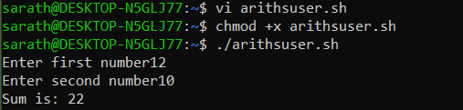

1. Shell script to demonstrate Arithmetic operators (addition, subtraction, multiplication, division, modulus, increment, decrement) by taking user input and store to another variable

vi filename.sh Press ‘i’ to INSERT

#!/bin/bash

read -p "Enter the First number: " num1 read -p "Enter the Second number: " num2 sum=$(( $num1 + $num2 ))

prd=$(( $num1 * $num2 )) diff=$(( $num1 - $num2 )) quo=$(( $num1 / $num2 )) rem=$(( $num1 % $num2 )) echo "Sum : $sum"

echo "Product : $prd" echo "Difference : $diff" echo "Quotient : $quo" echo "Remainder : $rem" if [ $num1 == $num2 ] then

echo "$num1 is equal to $num2"

fi

if [ $num1 != $num2 ] then

echo "$num1 is not equal to $num2"

fi

(( ++num1 ))

echo "Increment operator on first number: $num1" (( --num2 ))

echo "Decrement operator on second number: $num2" Press ‘Esc’ to end INSERT

:wq!

chmod +x filename.sh

./filename.sh Output:

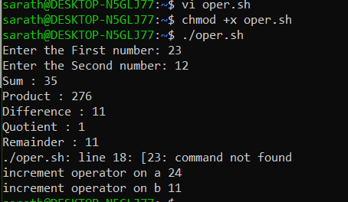

# Result:

Output displayed successfully and CO4 was obtained.

**Experiment 11 Date:** 04/04/2023

# Aim:

Familiarization of Linux Commands

# Course Outcome(CO4):

Write shell scripts required for system administration

# Procedure:

1. Shell script to demonstrate Relational operators (equal to, not equal to, greater than, less than, greater than or equal to, less than or equal to) by taking user input

vi filename.sh Press ‘i’ to INSERT #!/bin/bash

read -p "Enter the First number: " num1 read -p "Enter the Second number: " num2 if(( $num1 == $num2 ))

then

else fi

echo "== : $num1 is equal to $num2" echo "== : $num1 is not equal to $num2"

if(( $num1 != $num2 )) then

else fi

echo "!= : $num1 is not equal to $num2" echo "!= : $num1 is equal to $num2"

if(( $num1 > $num2 )) then

else fi

echo "> : $num1 is greater than $num2" echo "> : $num1 is not greater than $num1"

if(( $num1 < $num2 )) then

else fi

echo "< : $num1 is less than $num2" echo "< : $num1 is not less than $num2"

if(( $num1 >= $num2 )) then

else fi

echo ">= : $num1 is greater than or equal to $num2" echo ">= : $num1 is not greater than or equal to $num2"

if(( $num1 <= $num2 )) then

else fi

echo "<= : $num1 is less than or equal to $num2" echo "<= : $num1 is not less than or equal to $num2"

Press ‘Esc’ to end INSERT

:wq!

chmod +x filename.sh

./filename.sh Output:

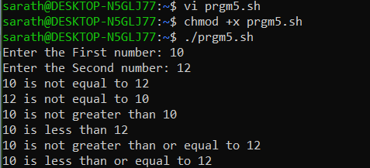

1. Shell script to demonstrate Relational operators (equal to, not equal to, greater than, less than, greater than or equal to, less than or equal to)

vi filename.sh Press ‘i’ to INSERT #!/bin/bash num1=54

num2=20

if [ $num1 -eq $num2 ] then

else fi

echo "-eq : $num1 is equal to $num2" echo "-eq: $num1 is not equal to $num2"

if [ $num1 -ne $num2 ] then

else fi

echo "-ne: $num1 is not equal to $num2" echo "-ne: $num1 is equal to $num2"

if [ $num1 -gt $num2 ] then

else fi

echo "-gt: $num1 is greater than $num2" echo "-gt: $num1 is not greater than $num1"

if [ $num1 -lt $num2 ] then

else fi

echo "-lt: $num1 is less than $num2" echo "-lt: $num1 is not less than $num2"

if [ $num1 -ge $num2 ] then

else fi

echo "-ge: $num1 is greater than or equal to $num2" echo "-ge: $num1 is not greater than or equal to $num2"

if [ $num1 -le $num2 ] then

else fi

echo "-le: $num1 is less than or equal to $num2" echo "-le: $num1 is not less than or equal to $num2"

Press ‘Esc’ to end INSERT

:wq!

chmod +x filename.sh

./filename.sh Output:

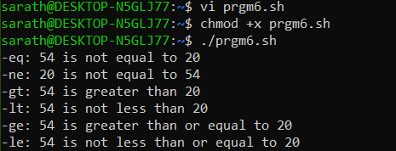

1. Shell script to demonstrate Logical operators (AND, OR, NOT) by taking user input

vi filename.sh Press ‘i’ to INSERT #!/bin/bash

read -p "Enter the First Boolean: " b1 read -p "Enter the Second Boolean: " b2 if(($b1 == "true" & $b2 == "true" )) then

else fi

echo Both are true echo Both are not true

if(($b1 == "true" || $b2 == "true" )) then

else fi

echo Atleast one of them is true echo None of them are true

if(( ! $b1 == "true" )) then

else fi

echo "b1" was initially false echo "b1" was initially true

Press ‘Esc’ to end INSERT

:wq!

chmod +x filename.sh

./filename.sh Output:

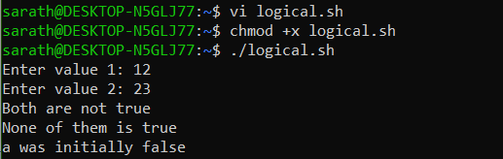

1. Write a shell script to check if a number is even or odd. vi filename.sh

Press ‘i’ to INSERT #!/bin/bash

read -p "Enter a Number: " num1 if(( $num1 == 0 ))

then

echo "$num1 is neither odd nor even number"

elif(( $num1 % 2 == 0 )) then

else fi

echo "$num1 is an even number" echo "$num1 is a odd number"

Press ‘Esc’ to end INSERT

:wq!

chmod +x filename.sh

./filename.sh Output:

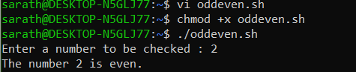

1. Write a shell script to check whether a number is positive or negative vi filename.sh

Press ‘i’ to INSERT #!/bin/bash

read -p "Enter a Number: " num1 if(( $num1 > 0 ))

then

echo "$num1 is a positive number" elif(( $num1 < 0 ))

then

else fi

echo "$num1 is a negative number" echo "$num1 is zero"

Press ‘Esc’ to end INSERT

:wq!

chmod +x filename.sh

./filename.sh Output:

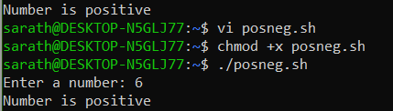

1. Write a shell script to find the greatest of two numbers vi filename.sh

Press ‘i’ to INSERT #!/bin/bash

read -p "Enter the first number: " num1 read -p "Enter the second number: " num2 if(( $num1 > $num2 ))

then

else fi

echo "$num1 is greater than $num2" echo "$num2 is greater than $num1"

Press ‘Esc’ to end INSERT

:wq!

chmod +x filename.sh

./filename.sh Output:

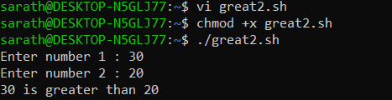

1. Write a shell script to find the greatest of three numbers vi filename.sh

Press ‘i’ to INSERT #!/bin/bash

read -p "Enter the first number: " num1 read -p "Enter the second number: " num2

read -p "Enter the third number: " num3 if(( $num1 > $num2 & $num1 > $num3 )) then

echo "$num1 is the greatest of the three" elif(( $num2 > $num3 ))

then

else fi

echo "$num2 is the greatest of the three" echo "$num3 is the greatest of the three"

Press ‘Esc’ to end INSERT

:wq!

chmod +x filename.sh

./filename.sh Output:

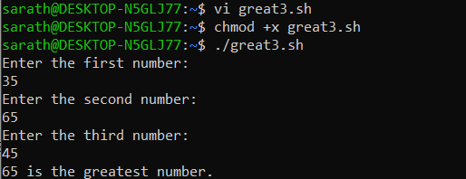

# Result:

Output displayed successfully and CO4 was obtained.

**Experiment 12 Date:** 11/04/2023

# Aim:

Familiarization of Linux Commands

# Course Outcome(CO4):

Write shell scripts required for system administration

# Procedure:

1. Shell script to demonstrate String operators (Equal, Not Equals, Size is zero, Size is non-zero, Empty string) by taking user input

vi filename.sh Press ‘i’ to INSERT #!/bin/bash

read -p "Enter the first string: " str1 read -p "Enter the second string: " str2 if(( $str1=$str2 ))

then

else fi

echo "Both strings are equal" echo "Both strings are not equal"

if(( $str1!=$str2 )) then

else fi

echo "Both strings are not equal" echo "Both strings are equal"

if(( -z$str1 )) then

else fi

echo "String size is zero" echo "String size is non-zero"

if(( -n$str1 )) then

else fi

echo "String size is non-zero" echo "String size is zero"

if(( $str1 )) then

else fi

echo "String is Empty" echo "String is not Empty"

Press ‘Esc’ to end INSERT

:wq!

chmod +x filename.sh

./filename.sh Output: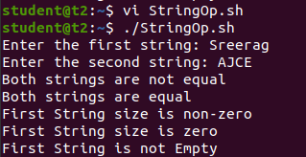

1. Shell script to demonstrate Bitwise operators (AND, OR, XOR, Complement, Right Shift, Left Shift) by taking user input

vi filename.sh Press ‘i’ to INSERT #!/bin/bash

read -p "Enter the first value: " bin1 read -p "Enter the second value: " bin2 result=$(( $bin1&$bin2 ))

echo "Bitwise AND: $result" result=$(( $bin1|$bin2 )) echo "Bitwise OR: $result" result=$(( $bin1^$bin2 )) echo "Bitwise XOR: $result" result=$(( ~$bin1 ))

echo "Bitwise COMPLEMENT of First Value: $result" result=$(( $bin1<<2 ))

echo "Bitwise RIGHT SHIFT(4) of First Value: $result" result=$(( $bin1>>2 ))

echo "Bitwise LEFT SHIFT(4) of Second Value: $result" Press ‘Esc’ to end INSERT

:wq!

chmod +x filename.sh

./filename.sh Output: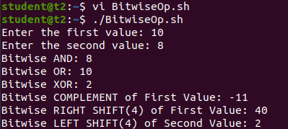

1. Shell script to demonstrate File Test operators (Exist(e), Size(s), Read Permission(r),

Execute Permission(x), Write Permission(w)) by taking user input

* 1. vi filename.sh
  2. Press ‘i’ to INSERT
  3. #!/bin/bash
  4. read -p "Enter file name: " f1
  5. if [ -e $f1 ]
  6. then
  7. echo "$f1 exist"
  8. else
  9. echo "$f1 does not exist"
  10. fi
  11. if [ -s $f1 ]
  12. then
  13. echo "$f1 is not empty"
  14. else
  15. echo "$f1 is empty"
  16. fi
  17. if [ -r $f1 ]
  18. then
  19. echo "$f1 has read permission"
  20. else
  21. echo "$f1 does not have read permission"
  22. fi
  23. if [ -x $f1 ]
  24. then
  25. echo "$f1 has execute permission"
  26. else

aa. echo "$f1 does not have execute permission"

bb. fi

cc. if [ -w $f1 ] dd. then

ee. echo "$f1 has write permission" ff. else

gg. echo "$f1 does not have write permission" hh. fi

ii. Press ‘Esc’ to end INSERT jj. :wq!

kk. chmod +x filename.sh ll. ./filename.sh

mm. Output:

nn. 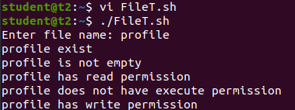

1. Shell Script to check if two numbers are equal using if statement
   1. vi filename.sh
   2. Press ‘i’ to INSERT
   3. #!/bin/bash
   4. read -p "Enter the first number: " num1
   5. read -p "Enter the second number: " num2
   6. if(( $num1==$num2 ))
   7. then
   8. echo "Both numbers are equal"
   9. fi
   10. if(( $num1!=$num2 ))
   11. then
   12. echo "Both numbers are not equal"
   13. fi
   14. Press ‘Esc’ to end INSERT
   15. :wq!
   16. chmod +x filename.sh
   17. ./filename.sh
   18. Output:

s.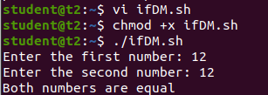

1. Shell Script to check the range of a number if numbers using else if ladder
   1. vi filename.sh
   2. Press ‘i’ to INSERT
   3. #!/bin/bash
   4. read -p "Enter the number(b/w 0-50): " num1

e. if(( $num1>=0&&$num1<=10 ))

1. then
2. echo "$num1 is between 0 and 10"

h. elif(( $num1>=11&&$num1<=20 ))

i. then

j. echo "$num1 is between 10 and 20"

k. elif(( $num1>=21&&$num1<=30 ))

1. then
2. echo "$num1 is between 20 and 30"

n. elif(( $num1>=31&&$num1<=40 ))

1. then
2. echo "$num1 is between 30 and 40"

q. elif(( $num1>=41&&$num1<=50 ))

1. then
2. echo "$num1 is between 40 and 50"
3. fi
4. Press ‘Esc’ to end INSERT
5. :wq!
6. chmod +x filename.sh
7. ./filename.sh
8. Output:

z. 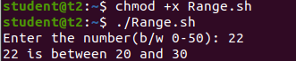

1. Shell Script to display the grade of a student by accepting his mark.

A